**Project Name: Restaurant Management System**

**My Name: Kumaran Varadaraju**

**Week 1 – CBAP**

**Identify Stakeholders**

*Internal Stakeholders* – Project Manager, Domain SME, Implementation SME, Operational Support Team, Testers, Business Analyst.

**Project Manager** —The Project Manager manages the change from the manual to the online system with the help of other stakeholders while ensuring they work accordingly.

**Domain SME**—Technical experts from the development team must recommend an application that ensures the ordering system is accessible without issue.

**Implementation SME** – To implement a new online system for ordering food and provide login access to Restaurant managers, Waiters, and CEOs.

**Operational Support Team**—To support when updating food items and online reservations in a new system, solve the issues during login, and attend to solve any issues related to accessing the new application within the requested time for a hassle-free online food management system.

**Testers**—Testers ensure the functionality of the created system before it is released to the end users and that there are no issues.

**Business Analyst** – Ensuring proper collaboration between external and internal stakeholders to implement successful solutions effectively.

*External Stakeholders* – Customer, Restaurant Manager, Waiter, Chefs, Delivery Agent, End User.

**Customer** – The restaurant that improves time management and efficiency in day-to-day management.

**Restaurant Manager**: Managers update the food menu, confirm table reservations, and enter customer feedback into the system.

**Waiter** – Waiters would recommend the tables and ensure the bills are generated from the system.

**End User** –Booking table reservations and ordering food online that gives customers comfort.

**Current State / As-Is Process (Flow Chart):**

**Tool Used -** [**https://app.diagrams.net/**](https://app.diagrams.net/)

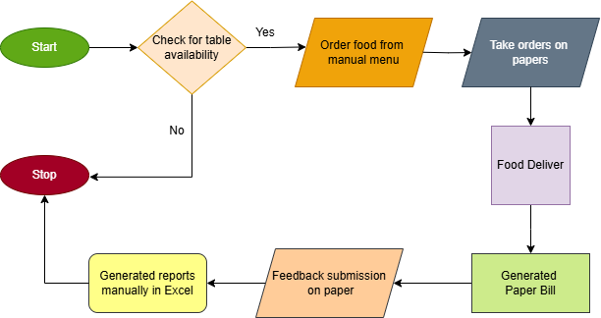

**Future State (Swimlane Diagram): Tool Used -** [**https://app.diagrams.net/**](https://app.diagrams.net/)

**Main Features:**

- All menu items should be categorized under any of the above headings.

- Each item should be saved in the system along with its price.

- Provides login access to required users.

- Waiters will be provided limited software access to recommend tables for customers and ensure system-generated bills.

- Managers should have access to add new items, delete existing items, and create new menus from scratch.

- The customer can book the table reservation online with no hassles.

- Customers should be comfortable accessing the menu and ordering food items.

- The system would replace manual data feed, which generates reports on sales, top dishes, and food availability.

**In Scope:**

- Manual menus would be replaced with an online system.

- Customers would be ordering food from the menu updated in the system.

- Customers could reserve tables in an online system, managers would make the reservations,

and waiters would recommend tables by checking the software.

- Waiters shall use the system to generate the bill table-wise.

- Customers can make payments in any form in the payment gateway.

- Managers will add customer feedback to the system.

**Out Scope:**

- Once the customer confirms the food order, it cannot be cancelled or edited.

- Management should provide prior information for non-working days, out-of-stock food items,

and Service unavailability.

**Functional Requirements:**

- The system should allow the managers to handle the reservations.

- The system should allow the managers to add, update, and remove menu items and their prices.

- The system should be able to generate the bill and accept any payment mode.

- Waiters and managers should be able to search items in the menu using the search facility.

- Waiters, managers, and James Oliver (CEO) will have login access and provide a password change facility.

**Non-Functional Requirements:**

- The system’s ability to handle multiple simultaneous users without significant slowdowns.

- Protect sensitive data such as sales, payment information and employee details by security systems.

- The integrated system is used with other systems, such as accounting software and delivery platforms.

- The system maintenance updates.



**Tool Used -** [**https://app.diagrams.net/**](https://app.diagrams.net/)

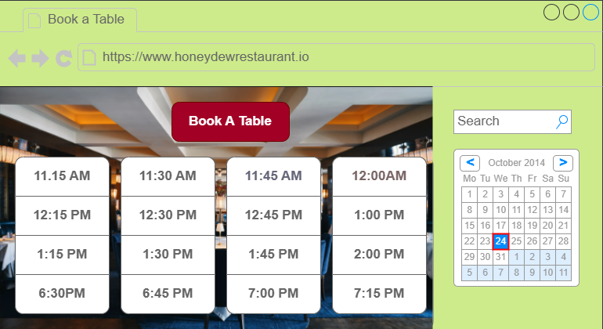

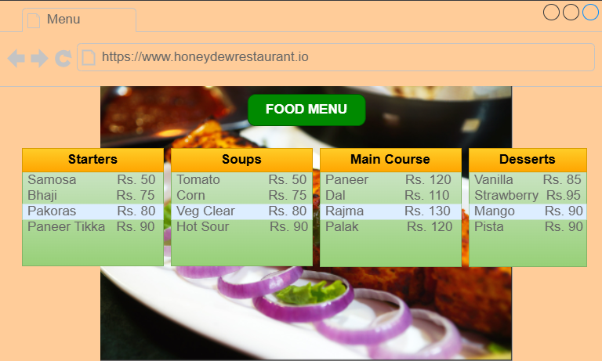

**Week 2 – Tableau**



**Tableau Public profile for this dashboard -https://public.tableau.com/app/profile/kumaran.varadaraju/viz/TableauCapstoneProject_17178805931930/Dashboard1?publish=yes**

**Week 3 – Excel**



